**Theoretical Neuroscience - Class Exercise (Hodgkin-Huxley)**

**Name ___Pranav Garg___________________________**

In this exercise you will interpret the results that Hodgkin-Huxley obtained & use these to explain Action potentials.

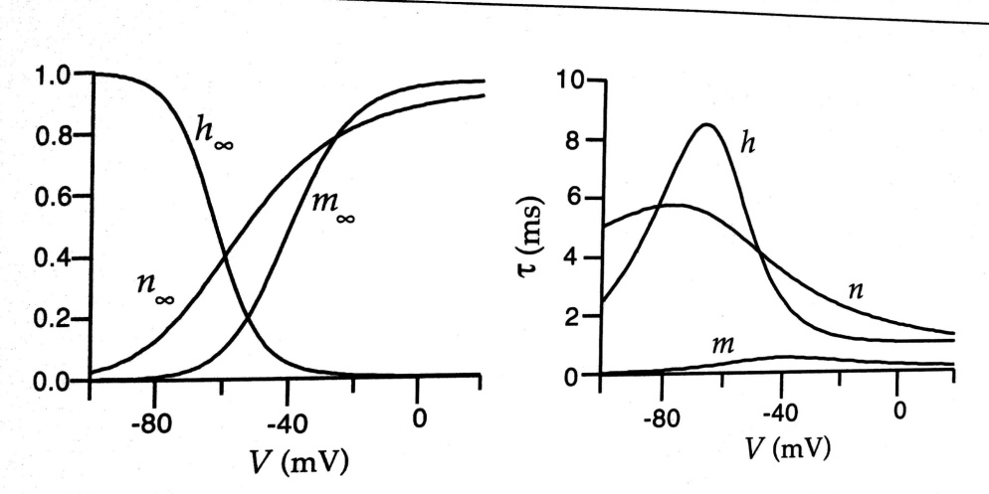

**At Rest**

1. At rest membrane potential, a large fraction of which *gates* are OPEN and which ones CLOSED?

h gates open. m gates closed

closed

1. At rest, are a large fraction of Sodium *channels* OPEN or CLOSED?
2. What about Potassium *channels*? Are a large fraction of potassium channels OPEN or CLOSED?

open

**Inject a step current & depolarize the membrane to -60 mV**

1. **Soon after (fraction of a msec)**

n=0.3 mV m=0.1 mV h=0.9 mV

* 1. What are the values of m, h, n ?
  2. Which *channels* are open in greater numbers – Sodium or potassium?

K

* 1. Does conductivity of membrane to potassium & sodium change soon after (within a fraction of a msec)? If so, then which one changes ?

Sodium

* 1. The step current injected into the axon had increased the membrane voltage? Once the step current has stopped will the membrane voltage increase further or will it decrease?

Will neither increase nor decrease

1. **After a few msec (let’s say 10 msec)**
   1. What are the values of m, h, n ?

H=n=0.4 m=0.1

* 1. What is the direction of net ionic flow ? Into the neuron or out of the neuron ?

Out of Neuron

**Inject a step current & depolarize the membrane to -30 mV**

1. **After a fraction of a msec** 
   1. What are the approximate values of m, h and n***?***

N= 0.6 h=0.1 m=0.6

* 1. Which channels (potassium & Sodium) are open?

Potassium

* 1. Is the Inward Sodium current or is the outward potassium greater?

Outward Potassium

1. **After 10 msec**
   1. What are the values of m, h, and n?

N=0.7 h=0 m=0.6

* 1. Which channels are open after 10 msec ?

Potassium

**Action Potential**

1. Use all of the above to explain to yourselves the origin of Action potential. Write down your explanation here. It will help me to figure out whether you have understood it all. If you have, then you don’t need me to explain it to you in the next class !

The potassium channels are open at -30 since they are open the net flow will be of K outside…this will create low conc inside and a spike which will soon subside because of the reverse flow of current.